John Michael Go
Career Entry Level Java Programming
Date: Jan. 11, 2013

DAY 1

Program Name: Age

Objective: Program will apply 20% for senior citizens.

Algorithm:

1. User inputs amount.
2. User inputs age.
3. Program will display 20% discount for senior citizens and none for not.

Flowchart:

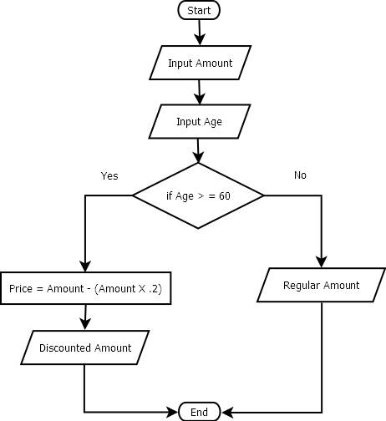

Pseudocode:

import java.util.*;

public class Age{

public static void main (String[]args){
// variable declaration
Scanner console = new Scanner(System.in);
double amt, prc;
int age;
// inputs amount
System.out.println ("");
System.out.print ("Enter Amount: ");
amt = console.nextInt();
System.out.println ("");
// inputs age
System.out.print ("Enter Age: ");
age = console.nextInt();
System.out.println ("");
// system determines age if discount is applicable
System.out.println ("===============================================================================");
System.out.println ("");
if (age>=60){
prc=amt-(amt*0.2);
System.out.println ("The discounted price for senior citizens will be " +String.format("%.2f", prc));
System.out.println ("");
System.out.println ("");
System.out.println ("");
} else{
System.out.println ("The price will still be " +String.format("%.2f", amt));
System.out.println ("");
System.out.println ("");
System.out.println ("");
}

}

}

Screenshot:

